**Lab Exercise 5– Terraform Variables with Command**

**Line Arguments** **Objective:**

Learn how to pass values to Terraform variables using command line arguments.

**Prerequisites:**

* Terraform installed on your machine.
* Basic knowledge of Terraform variables.

**Steps:**

1. **Create a Terraform Directory:**
2. 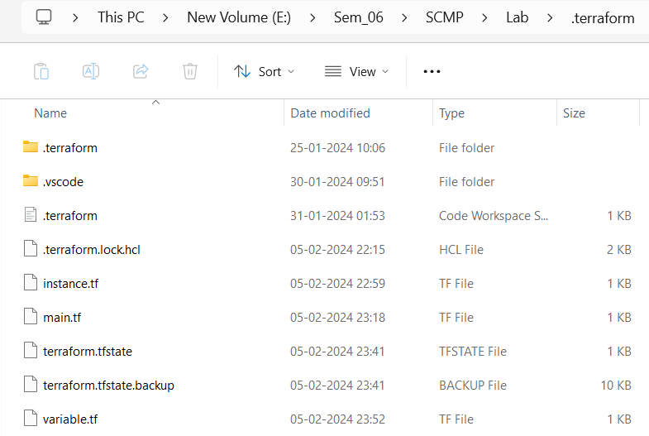
3. **Create Terraform Configuration Files:** 
   * Create a file named main.tf:

# main.tf Create a file named variables.tf:

# variables.tf

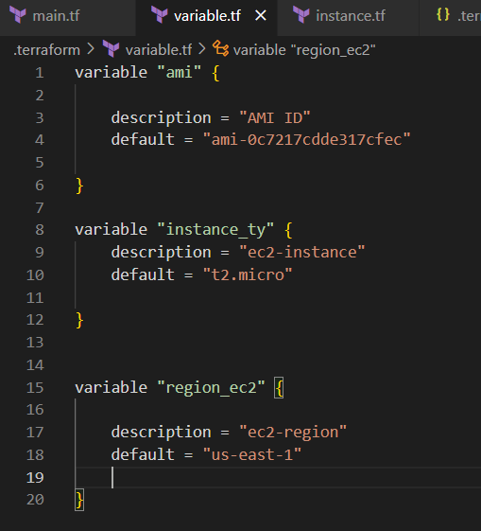

1. **Use Command Line Arguments:**

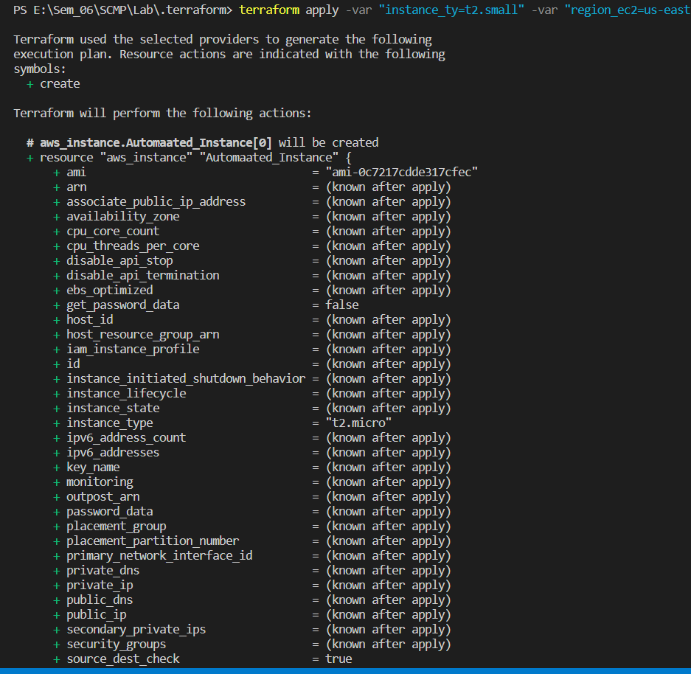

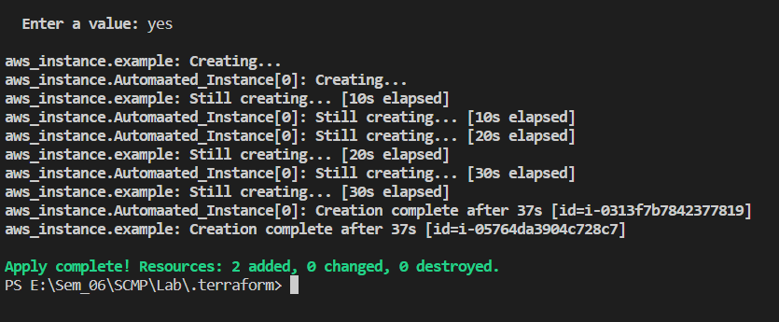

1. **Test and Verify:**



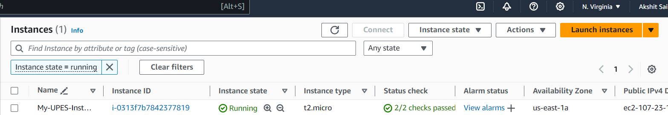

1. **Clean Up:**

